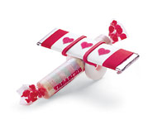

Candy Airplane

Assembling this valentine requires a little bit of tricky balancing, but once you catch on, these sweet crafts will be flying from your fingertips.

Craft Supplies:
- Thin Rubber band
- Peppermint Life Savers
- Smarties
- Cinnamon Gum
- Heart Shaped Stickers

Time Needed: Under an hour

1. Thread the rubber band through the holes of two Life Savers, then balance the roll of Smarties between them, across the rubber band.
2. For wings, balance the stick of gum on top, perpendicular to the Smarties, and pull the rubber band up and over each side of the gum to hold it all in place.
3. Decorate the wings with tiny heart-shaped stickers or a message.
Tips:
If smaller fingers are having trouble with all that balancing and stretching, have one person hold the candy in place while another works the rubber band up and over the gum.

Taken from www.familyfun.com/arts-and-crafts

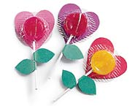

Lollipop Flowers

There is something irresistibly simple and lovely about this card, and your sweetheart is sure to be a sucker for the candy treat it hides.

Craft Supplies:
- Red and Green Construction Paper or Card stock
- Scissors
- Lollipops
- Glue Stick

Time Needed: Under 1 hour

1. From red construction paper, cut out a heart that's just larger than the lollipop candy and glue it to the wrapper.
2. For the leaves, fold the green paper in half and cut out a leaf shape, leaving the two sides attached at the seam.
3. Unfold the double leaf shape, coat the entire inside surface with glue, and fold it back over the lollipop stem, pressing to secure.
Tips:
If you use cardboard templates, one child can trace and cut hearts while another works on the leaves.
Variations:
Make cardboard templates of the hearts and leaves.

Taken from www.familyfun.com/arts-and-crafts

